**Biology STAAR Review Stations**

**Day 10**

**Category # 4 Biological Processes and Systems (10.A, 10.B, 10.C)**

10.A describe the interactions that occur among systems that perform the functions of regulation, nutrient absorption, reproduction, and defense from injury or illness in animals

10.B describe the interactions that occur among systems that perform the functions of transport, reproduction, and response in plants

10.C analyze the levels of organization in biological systems and relate the levels to each other and to the whole system

**10.A, 10.B, 10.C Pre-Test Score__________ Focus TEKS__________**

|  |  |  |  |  |
| --- | --- | --- | --- | --- |
|  | **10.A** | **10.B** | | **10.C** |
| **Interactive Quizzes** | **Interactions of Body Systems**  <http://www.proprofs.com/quiz-school/story.php?title=interactions--human-body-systems> | **Plant Systems Quiz**  <http://wps.pearsoned.com.au/sf2_2/134/34366/8797822.cw/index.html> | | **Levels of Organization**  <http://www.proprofs.com/quiz-school/story.php?title=levels-organization-quiz> |
| **Graphic Organizers** | **Organ Systems Graphic Organizer**  See handout | **Interactions of Plant Systems Table**  Use the following link to complete the Plant System Table:  <http://teacherweb.com/TX/roberteleehighschool/Biology/10B-2-signed.pdf> | | **Human Body Graphic Organizer**  **See handout** |
| **Virtual Labs** | **How does the body protect itself against foreign substance?**  **http://www.glencoe.com/sites/common_assets/science/virtual_labs/LS27/LS27.html** | **Exploring Plant Responses**  [**https://www.classzone.com/books/hs/ca/sc/bio_07/virtual_labs/virtualLabs.html**](https://www.classzone.com/books/hs/ca/sc/bio_07/virtual_labs/virtualLabs.html) | | **Circulatory Physiology**  [**http://www.phschool.com/science/biology_place/labbench/lab10/intro.html**](http://www.phschool.com/science/biology_place/labbench/lab10/intro.html) |
| **Vocabulary** | **Homeostasis and the Organization of the Human Body Flashcards**  <http://www.cram.com/flashcards/homeostasis-and-the-organization-of-the-human-body-406558> | | **Plant Systems Flashcards**  <http://quizlet.com/10585098/10b-plant-systems-flash-cards/> | **Body Systems Flashcards**  <http://quizlet.com/7294628/human-body-systems-flash-cards/> |
| **Video Clips** | **Nutrient Absorption Video Clip**  <http://www.educreations.com/lesson/view/nutrient-absorption/2381060/?ref=appemail>  **Animal Defense Video**  [**http://www.educreations.com/lesson/view/animal-systems-defense-b10a/2388923/?s=E20raS&ref=appemail**](http://www.educreations.com/lesson/view/animal-systems-defense-b10a/2388923/?s=E20raS&ref=appemail)  **Regulation Video**  [**http://www.educreations.com/lesson/view/b10a-regulation/2390272/?s=IvDvPs&ref=appemail**](http://www.educreations.com/lesson/view/b10a-regulation/2390272/?s=IvDvPs&ref=appemail)  Take notes over the video clips. | | **Plant Reproduction in Angiosperms**  <http://www.youtube.com/watch?v=HLYPm2idSTE&feature=youtu.be> | **Human Body Systems: The 11 Champions**  <https://www.youtube.com/watch?v=nnjmrrQ6xOs> |

**10.A, 10.B, 10.C Post-Test Score__________**

**Notes:**

**Critical Thinking Questions**

1. How do systems in animals interact to achieve nutrient management?

2. Which systems in animals interact to achieve reproduction?

3. How do systems in animals interact to protect them from injury or illness?

4. What is the role of homeostasis in system regulation?

5. Describe some of the plant responses to different stimuli.

6. Discuss the organization of the basic unit of life to the most complex body systems.

**10.A Organ Systems Graphic Organizer**

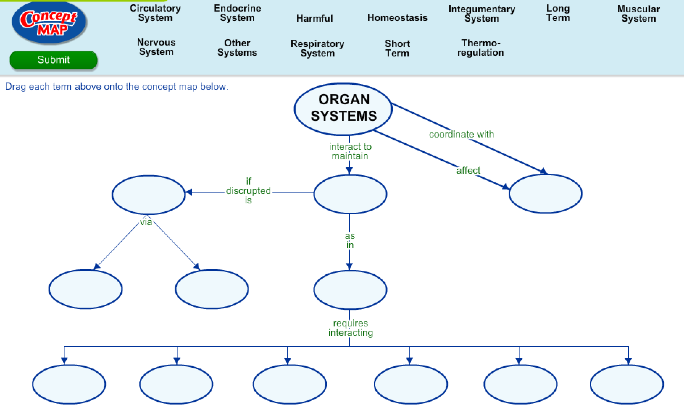

**10.B Interactions of Plant Systems Table**

Use the following link to describe how plant systems regulate transport, response, reproduction and co-evolution with birds/bugs.

<http://teacherweb.com/TX/roberteleehighschool/Biology/10B-2-signed.pdf>

**Describe how plants regulate the following**:

|  |  |
| --- | --- |
| **Transport** | **Response** |
| **Reproduction** | **Co-evolution with birds/bugs** |

**10.C Human Body Graphic Organizer**

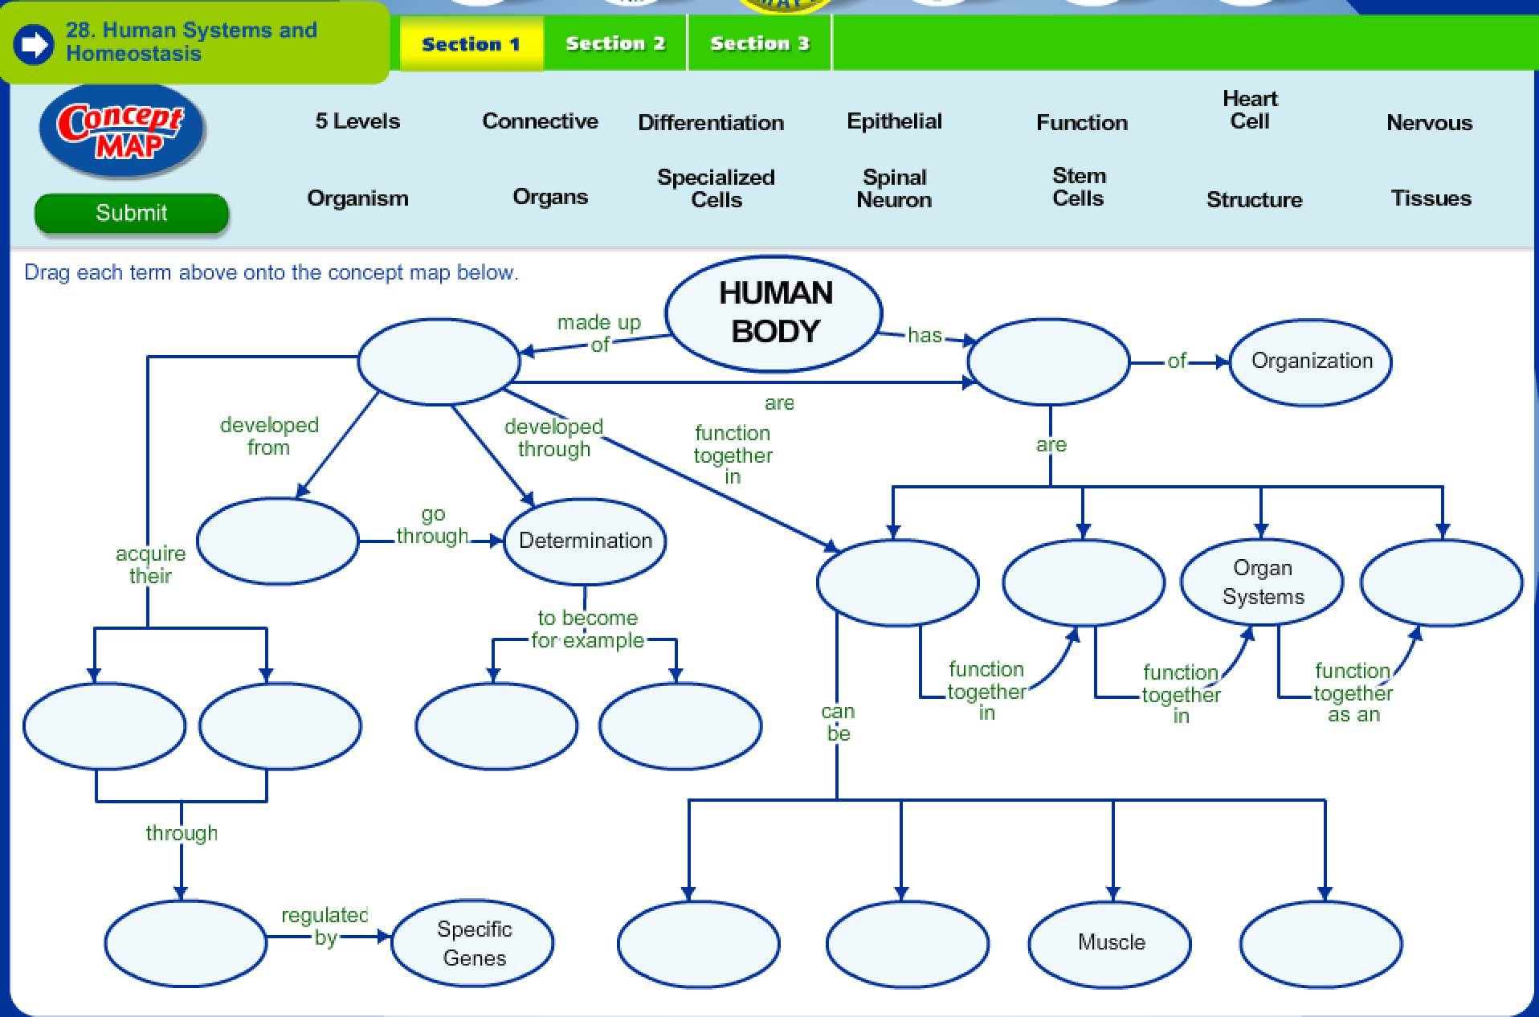

**Day 10 Review Questions**

10.A

_____1. How do the respiratory and circulatory systems interact?

1. the circulatory system transports absorbed nutrients from the small intestine to the cells
2. the circulatory system transports hormones from endocrine glands to target body cells
3. the circulatory system transports oxygen from the lungs to the cells and carbon dioxide from the cells to the lungs
4. the circulatory system transports nitrogen wastes from proteins to the kidneys where they are converted to urea and excreted from the body

10.A

_____2. Health-care workers are exposed to many different types of pathogenic and nonpathogenic microorganisms. Which body systems work together to protect the body from pathogens?

a. Muscular and vascular

b. Digestive and excretory

c. Circulatory and immune

d. Endocrine and reproductive

10.A

_____3. The human digestive system is approximately 900 cm long. Food is moved through the digestive tract primarily by —

a. bile produced by the pancreas

b. the enzymes amylase and pepsin

c. muscular contractions

d. hydrochloric acid in the stomach

10.A

_____4. Which of the following correctly describes an interaction that occurs between two body systems of a rabbit that helps the rabbit outrun a pursuing coyote?

1. The skeletal system releases additional calcium, and the circulatory system retains more sodium in the blood to provide muscles with ions for contraction.
2. The digestive system increases the rate of digestion, and the excretory system ceases to provide tissues with more nutrients.
3. The respiratory system increases the breathing rate, and the circulatory system increases blood pressure to provide tissues with more oxygen.
4. The endocrine system releases hormones that prepare the immune system to deal with possible injuries.

10.B  
_____5. Plants can capture solar energy and carry on ______, a process that allows them to make their own food.

1. photosynthesishttps://highered.mcgraw-hill.com/olcweb/styles/shared/spacer.gif
2. adaptation
3. homeostasis https://highered.mcgraw-hill.com/olcweb/styles/shared/spacer.gifhttps://highered.mcgraw-hill.com/olcweb/styles/shared/spacer.gif
4. metabolism

10.B

_____6. Why must the different systems of a plant interact for the plant to survive?

1. the different systems need to function independently
2. plants do not have separate systems therefore they cannot interact
3. each individual system is specialized and cannot function on its own
4. none of the above

10.B

_____7 What tissue conducts water and nutrients in a plant?

1. Dermal tissue
2. Vascular tissue
3. Ground tissue
4. Epidermal tissue

10.B

_____8. Which of the following is NOT a function of a plant root?http://highered.mcgraw-hill.com/olcweb/styles/shared/spacer.gif http://highered.mcgraw-hill.com/olcweb/styles/shared/spacer.gif

1. absorb water from the soilhttp://highered.mcgraw-hill.com/olcweb/styles/shared/spacer.gif
2. absorb minerals from the soilhttp://highered.mcgraw-hill.com/olcweb/styles/shared/spacer.gif
3. anchors a plant in the soilhttp://highered.mcgraw-hill.com/olcweb/styles/shared/spacer.gif
4. site of photosynthesis

10.C

http://glencoe.mcgraw-hill.com/olcweb/styles/shared/spacer.gif_____9. Identify the correct order of organization:

a. cell-tissue-organ-organ system-organism

b.tissue-cell-organism-organ system-organ

c. organ system-organism-cell tissue-organ

d. cell-organ-tissue-organ system-organism

10.C

_____10. The ____ maintain homeostasis by removing wastes and excess water.**[[http://glencoe.mcgraw-hill.com/olcweb/styles/shared/spacer.gif](http://glencoe.mcgraw-hill.com/sites/0078802849/student_view0/unit9/chapter34/standardized_test_practice-english.html#quest13)](http://glencoe.mcgraw-hill.com/sites/0078802849/student_view0/unit9/chapter34/standardized_test_practice-english.html" \l "quest13)**

a. dendriteshttp://glencoe.mcgraw-hill.com/olcweb/styles/shared/spacer.gif

b. lungshttp://glencoe.mcgraw-hill.com/olcweb/styles/shared/spacer.gif

c.http://glencoe.mcgraw-hill.com/olcweb/styles/shared/spacer.gifurethrashttp://glencoe.mcgraw-hill.com/olcweb/styles/shared/spacer.gif

d. kidneys

10.C

_____11. All systems of the body contribute to homeostasis. The ______ systems coordinate the activities of the other systems.https://highered.mcgraw-hill.com/olcweb/styles/shared/spacer.gifhttps://highered.mcgraw-hill.com/olcweb/styles/shared/spacer.gifhttps://highered.mcgraw-hill.com/olcweb/styles/shared/spacer.gif

1. excretoryhttps://highered.mcgraw-hill.com/olcweb/styles/shared/spacer.gif https://highered.mcgraw-hill.com/olcweb/styles/shared/spacer.gif
2. respiratory
3. nervous and hormonal
4. digestive

https://highered.mcgraw-hill.com/olcweb/styles/shared/spacer.gif10.C  
_____12. Living things respond to external stimuli. Which of the following is NOT a response to a stimulus?https://highered.mcgraw-hill.com/olcweb/styles/shared/spacer.gif

1. A houseplant, when placed near a window, bends its stem to face the sun.https://highered.mcgraw-hill.com/olcweb/styles/shared/spacer.gif
2. The pupils of the human eye dilate in a dark environment.https://highered.mcgraw-hill.com/olcweb/styles/shared/spacer.gif
3. Touching a hot stove causes the hand to quickly move away.
4. Organs are composed of tissues, and each tissue contains groups of similar cells.

**Body System Matching Activity**

|  |  |
| --- | --- |
| What do **arteries** do? | **Carry oxygenated blood away from the heart.** |
| What do **veins** do? | **Carry deoxygenated blood to the heart.** |
| What do **capillaries** do? | **They are the smallest vessels that deliver oxygen to individual cells.** |
| What is the function for **red blood cells**? | **Carry oxygen** |
| Why is the red-blood cell shaped like a donut? | **The shape allows the cell to carry the maximum amount of oxygen.** |
| Why are cells **shaped** differently? | **The shape of the cell is related to the function of the cell.** |
| What is the function of the **air sacs** (alveoli) in the lungs? | **To gather oxygen from the lungs and carry it to the capillaries.** |
| What are the functions of **white blood cells**? | **Defense, fight pathogens, and are part of the immune system** |
| What causes the disease **diabetes**? | **Blood sugar levels are too high and cannot be controlled.** |
| What are **involuntary** muscles and give an example. | **Muscles that work on their own such as the heart, stomach and intestines.** |
| What are **voluntary** muscles and give an example. | **Muscles that humans can control such as skeletal muscles.** |
| What type of cell **carries** **impulses to and from the brain and spinal cord**? | **Neurons** |
| During digestion, what is the main function of the **large intestine**? | **Removes water and makes feces** |
| During digestion, what is the main function of the **small intestine**? | **Digestion and absorption of food** |
| During respiration, which gas is removed and exhaled from the body? | **Carbon Dioxide** |
| During respiration, which **gas is taken into our body**? | **Oxygen** |
| How do fish **control the depth they swim**? | **The swim bladder aids in controlling the depth.** |
| How do fish “**hear**”? | **Fish have lateral lines that help them “hear”.** |
| What is the **autonomic nervous system** and what are some functions it controls? | **The system works automatically to regulate body temperature and blood sugar levels.** |
| Which **system** is involved when you experience an “**allergy attack**”? | **The immune system. Symptoms are sneezing and itchy, watery eyes.** |
| What effect does **adrenaline** (hormone) have on your body when it is released? | **“Fight or Flight”—an increase of heart rate, increased blood vessel dilation and increased breathing rate** |
| Which organ **releases hormones** to control **glucose levels** in the blood? | **Pancreas** |
| Which system is involved with the **removal of urea** from cells **creating urine**? | **Excretory** |
| Which system is involved with **making feces**? | **Digestive System** |
| If white blood cells attack any of your body cells, what type of **disease** (category) would that be? | **Autoimmune** |
| Which **organ removes metabolic wastes from the blood**? | **Kidneys** |
| What are the **sensory organs**? | **Eyes, skin, tongue, skin and nose** |
| What triggers the “**flight-or-fight**” response? | **Release of hormones and the activation of the sympathetic nervous system** |

**Day 10 Review Questions (10.A, 10.B, 10.C)**

**Answer Sheet**

**_____1.**

**_____2.**

**_____3.**

**_____4.**

**10.A Score__________/4**

**_____5.**

**_____6.**

**_____7.**

**_____8.**

**10.B Score__________/4**

**_____9.**

**_____10.**

**_____11.**

**_____12.**

**10.C Score__________/4**

**Day Ten Review Questions (10.A, 10.B, 10.C)**

**Key**

**__C__1.**

**__C__2.**

**__C__3.**

**__C__4.**

**__A__5.**

**__C__6.**

**__B__7.**

**__D__8.**

**__A__9.**

**__D__10.**

**__C__11.**

**__D__12.**